Still Puritan after All These Years
AUG. 3, 2012
By MATTHEW HUTSON
“I THINK I can see the whole destiny of America contained in the first Puritan who landed on those shores,” the French political thinker Alexis de Tocqueville wrote after visiting the United States in the 1830s. Was he right? Do present-day Americans still exhibit, in their attitudes and behavior, traces of those austere English Protestants who started arriving in the country in the early 17th century?
It seems we do. Consider a series of experiments conducted by researchers led by the psychologist Eric Luis Uhlmann and published last year in the Journal of Experimental Social Psychology. In one study, they investigated whether the work habits of today’s Americans reflected the so-called Protestant work ethic. Martin Luther and John Calvin argued that work was a calling from God. They also believed in predestination and viewed success as a sign of salvation. This led to belief in success as a path to salvation: hard work and good deeds would bring rewards, in life and after.
In the study, American and Canadian college students were asked to solve word puzzles involving anagrams. But first, some were subtly exposed to (or “primed” with) salvation-related words like “heaven” and “redeem,” while others were exposed to neutral words. The researchers found that the Americans — but not the Canadians — solved more anagrams with salvation on the mind. They worked harder.
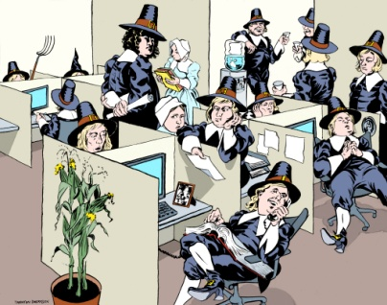
Professor Uhlmann and his colleagues also conducted an experiment to see if Americans shared the prudishness of the Puritans. They found that American students judged promiscuous women more harshly than British students did.
In a third experiment, the researchers asked Asian-Americans to rate their support for a school principal who had canceled a prom because of sexually charged dancing and also to rate their support for a school that had banned revealing clothing. But first, the researchers primed the participants with thoughts of either their Asian or their American heritage, as well as with thoughts of work or another topic. They found that the participants showed increased approval of the prudish school officials when primed with thoughts of work — if they had also been primed with their American heritage, but not when primed with their Asian heritage. These results suggest a tight Puritanical intermingling of work, sex and morality in the American mind.
In none of these studies did the results hinge on the participants’ religious affiliation or level of religious feeling. Whatever these Americans explicitly believed (or didn’t believe) about God, something like Puritan values seemed to be guiding their moral judgments.
Protestant attitudes about work may also influence how Americans treat their co-workers. Calvin argued that socializing while on the job was a distraction from the assignment God gave you. The psychologist Jeffrey Sanchez-Burks has found that Protestants — but not Catholics — become less sensitive to others’ emotions when reminded of work, possibly indicating a tendency to judge fraternizing as unproductive and unprofessional. He and collaborators have also found that Americans have a culturally specific tendency to view family photos and other personal items as unprofessional presences in the office.
Not all of the legacy of Puritanism suggests moral uprightness. Studies since the ’70s have also found that Americans who score high on a Protestant Ethic Scale (emphasizing self-reliance and self-discipline) or similar metric show marked prejudice against racial minorities and the poor; hostility toward social welfare efforts; and, among obese women, self-denigration.

Why the persistence of Puritanism in American life? “New England exercised a disproportionate influence on American ideals,” the historian John Coffey says, “thanks to a powerful intellectual tradition disseminated through its universities, its dynamic print culture and the writings of its famous clergy.” He also notes the power of Evangelicalism as a carrier of Puritan values and America’s resistance, compared with other largely Protestant nations, to secularization.
It’s hard to say for sure that any given element of the American psyche results from our Puritan founders. “The direct lines are few,” stresses David D. Hall, a professor of New England church history, “mostly because of industrialization and immigration” and other factors that have led to immense social change.
But were Tocqueville to land on our shores today, with a bit of squinting he would probably see some of the same evidence of our Puritan destiny as he did nearly two centuries ago.
Matthew Hutson is the author of the book “The 7 Laws of Magical Thinking: How Irrational Beliefs Keep Us Happy, Healthy, and Sane.”

