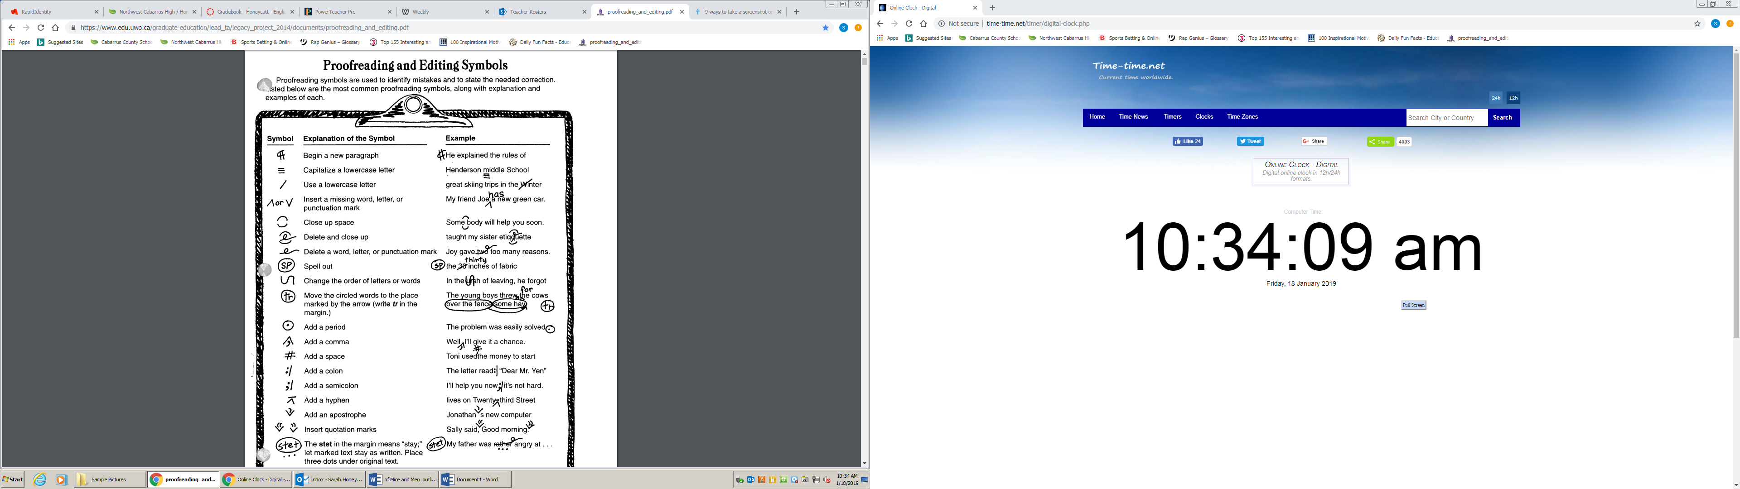

P/A Check for Pronoun-Antecedent Everyone left their books in class when we

Agreement went to the gym.

S/V Check for Subject-Verb Agreement The women was happy to be home.

Run. Run-on sentence My dad ran a red light then he got a ticket.

Inc./ Incomplete/Fragment Because it was raining.

Frag.

☹ Not a word Examples: gonna, imma, hafta