Determining Purpose and Tone:

- Working alone or with a partner (your choice this time, but NO MORE than two people working together), complete the other side of this paper by ONE of the following methods:
  - Write on the chart (hard copy to turn in)
  - Complete electronically on chart by accessing the document from my website: sjhoneycutt.weebly.com
  - Make a PowerPoint/Slide Share with the information from each row of the chart on a slide:
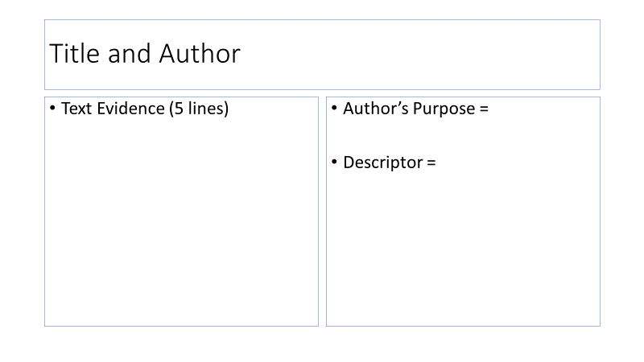
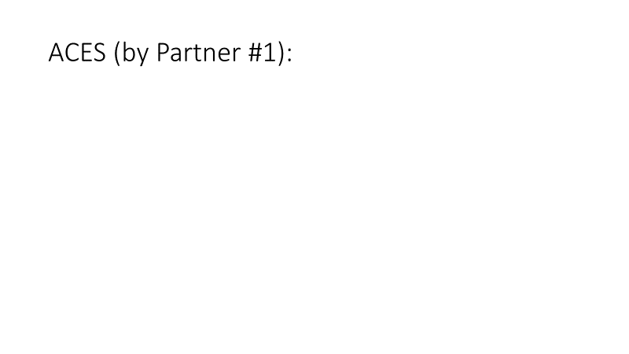
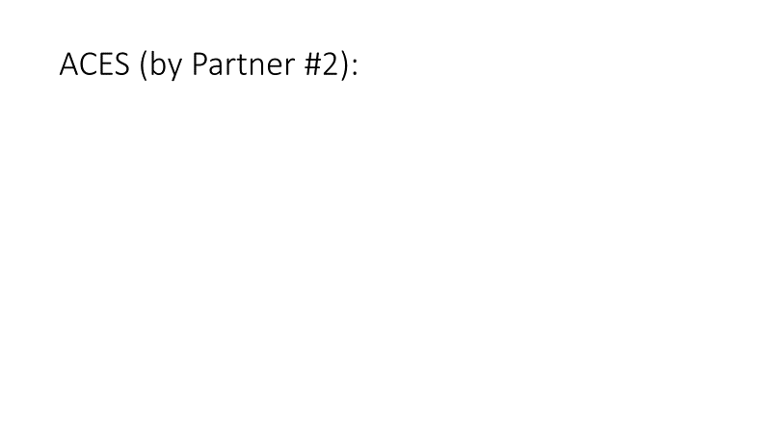

(x3)

*Any electron submissions need to be shared via Google Drive: sarah.honeycutt@apps.cabarrus.k12.nc.us

- EACH person must write an ACES paragraph for the following prompt and include the following:
  - Source credit (name of title and author)
  - A specifically identified tone
  - TWO examples of text evidence to support the tone
  - Elaboration proving how the examples develop/support the tone (what they mean/imply)
  - A summary sentence
  - Adherence to basic grammar and spelling rules

If you choose to complete the chart on the reverse side, you may write your ACES below:

